

Memo

To: **Expenses**

From: **Joanna Barchet**

Date: **18/10/2024**

Re: **New Bursary Payments for Studentship holder**

Dear Expenses,

Please could you set up a new bursary account for the following student, a bursary funded PhD student who started on 27 June 2024. They are based in theSchool of Animal, Rural and Environmental Sciences, NTU Doctoral School Office, 50 Shakespeare Street.

Name: Alex Nduah Nderi

Address:  P.O. Box 287 - 01020 Kenol, Kenya

Student Id:      N1335628

Duration: 4

Bank Name:   Kenya Commercial Bank

Branch:      Moi Avenue

Account number:   1236401220

Swift code: KCBLKENX

Budget code:

**PV01 0785 XS073**

Budget holder name and signature:

**Prof Mazeda Hossain**

**Director – NTU Eastern Africa Centre (EAC)**

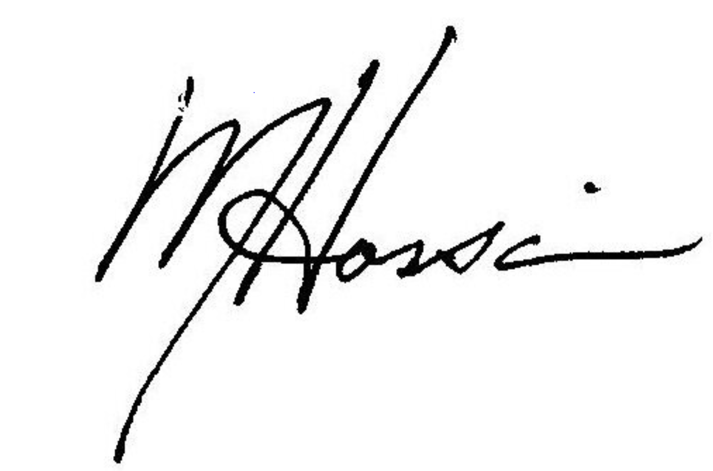

Bursary details:

Year 1 £6969.60

Year 2 £7666.60

Year 3 £8433.20

Year 4 £9276.50

Budget code:

**PV01 0785 XS073**

Budget holder name and signature:

**Prof Mazeda Hossain**

**Director – NTU Eastern Africa Centre (EAC)**



First payment: 27 July 2024

Many thanks in advance.

Best wishes,

Joanna Barchet

Doctoral School Coordinator

50 Shakespeare Street

Email: doctoralschool@ntu.ac.uk

Ext: 84092